IAM & Least Privilege Enforcement
Unit 2 — Cloud Security Assignment Report
Prepared by: Kaveri Rajguru
AWS Account ID: 429240130873
Region: eu-north-1 (Europe – Stockholm)
Tool used: Terraform v1.16.2

1. Objective
This project implements a rigorous AWS Identity and Access Management (IAM) structure following the Principle of Least Privilege. It creates three distinct IAM groups (Admins, Developers, Auditors) each with a custom, scoped policy; enforces Multi-Factor Authentication (MFA) for the Admins group; and provisions a custom IAM Role that allows an EC2 instance to access S3 securely without any hardcoded credentials.

2. Architecture Summary
- Admins — broad operational access (EC2, S3, IAM group/role management, CloudWatch/Logs), explicitly denied billing and AWS Organizations actions so even the admin tier is not root-equivalent.
- Developers — can run/stop/terminate EC2 instances and read/write only the project's S3 bucket; IAM actions are explicitly denied.
- Auditors — strict read-only access (Get*/List*/Describe*) across IAM, S3, EC2, CloudTrail and Config for compliance review, with no write permissions anywhere.
- MFA Enforcement — an additional policy attached to the Admins group denies nearly all actions unless the caller has authenticated with MFA, while still allowing users to enrol and manage their own MFA device.
- EC2 → S3 Role — a custom IAM Role (EC2-S3-Access-Role) with an instance profile lets an EC2 instance assume temporary credentials scoped to one S3 bucket only, eliminating the need for hardcoded access keys.

3. IAM Policy Matrix
Group | Key Permissions | Explicit Restrictions
Admins | EC2:*, S3:*, IAM group/role mgmt, CloudWatch:*, Logs:* | Deny billing, Organizations, account actions; MFA required for all actions
Developers | EC2 run/start/stop/terminate, S3 Get/Put/List on app bucket only | Deny all IAM:* actions
Auditors | IAM/S3/EC2 Get*/List*/Describe*, CloudTrail, Config read access | No write, create, or delete actions anywhere

4. Terraform Deployment Evidence
The infrastructure above was defined entirely in Terraform (HCL) and deployed to a real AWS account. The following screenshots document each stage of deployment, from admin-user setup through final verification in the AWS Console.
Screenshot 1 — IAM Admin User Created
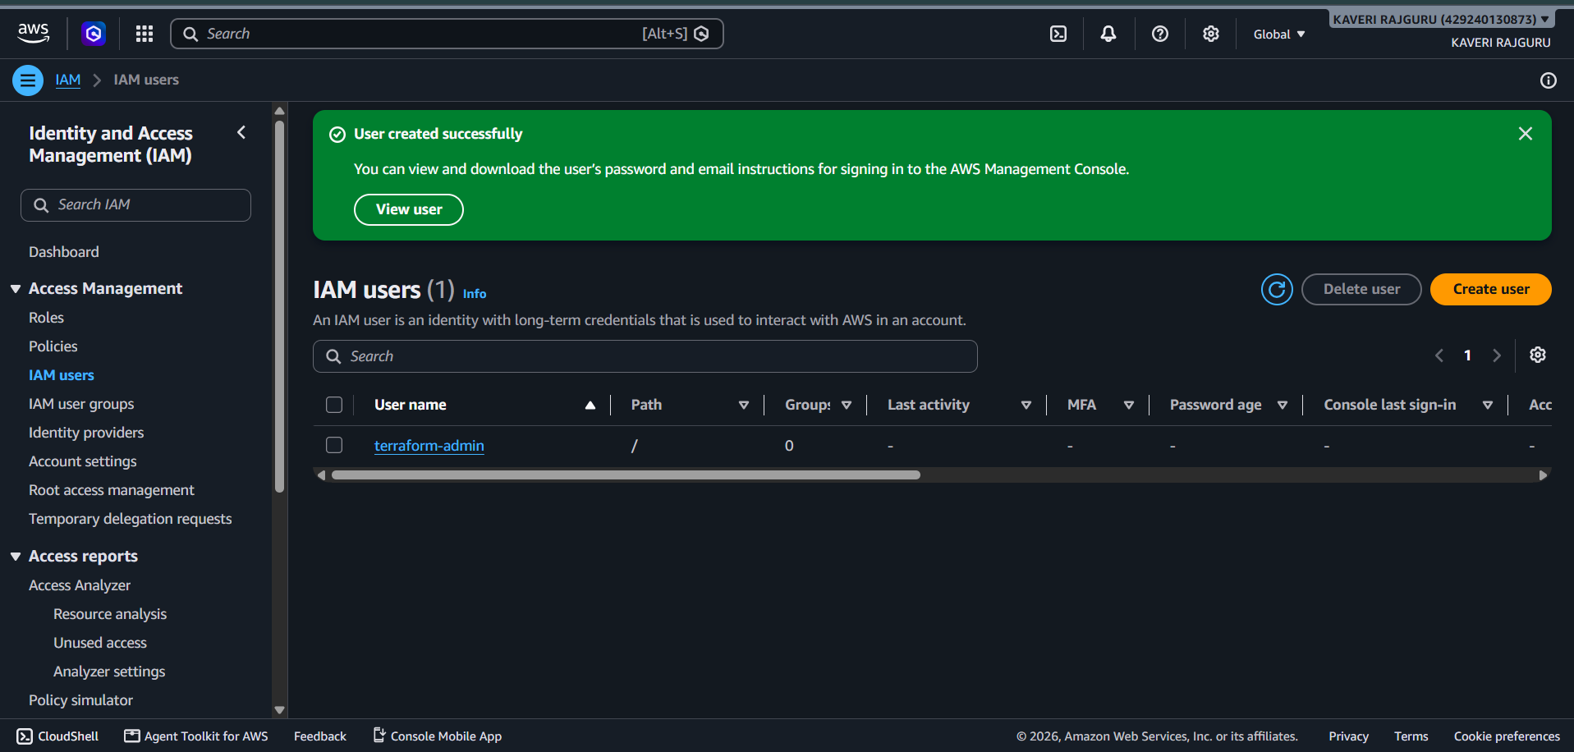
A dedicated IAM user (terraform-admin) with AdministratorAccess was created instead of using the AWS root account for daily operations, following AWS security best practice.
Screenshot 2 — terraform init
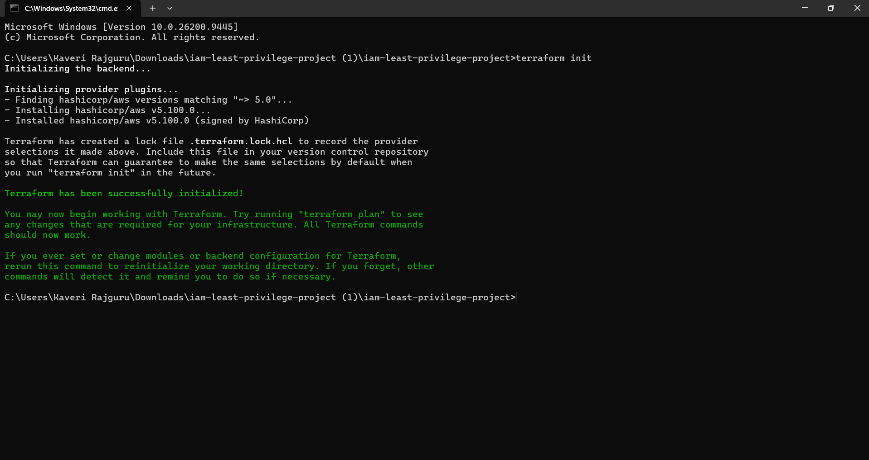
Terraform successfully initialized the working directory and downloaded the AWS provider (hashicorp/aws v5.100.0).
Screenshot 3 — terraform apply
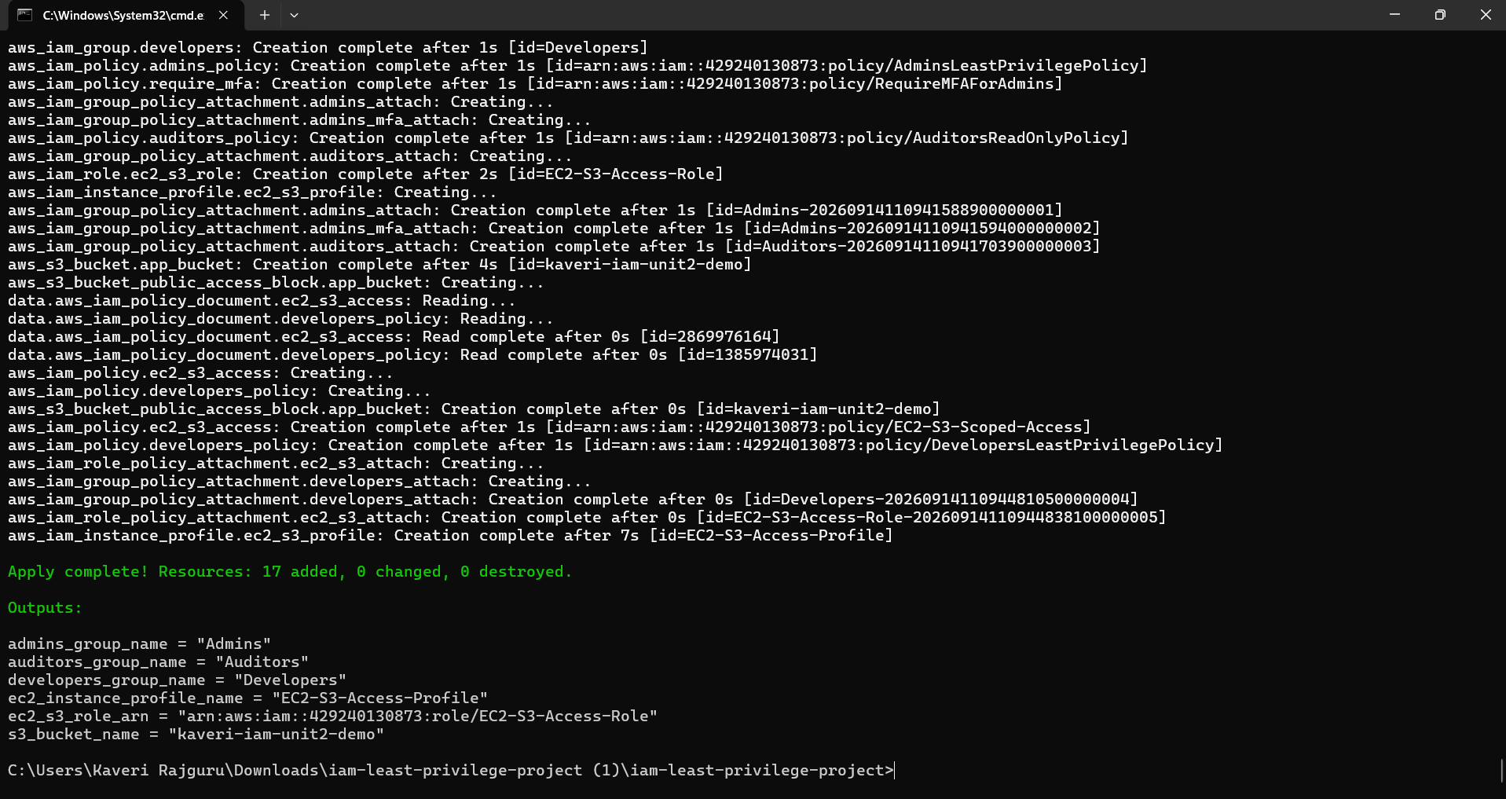
Terraform applied the configuration and created all 17 planned resources (IAM groups, policies, role, instance profile, and S3 bucket) with zero errors.
Screenshot 4 — IAM Groups Created
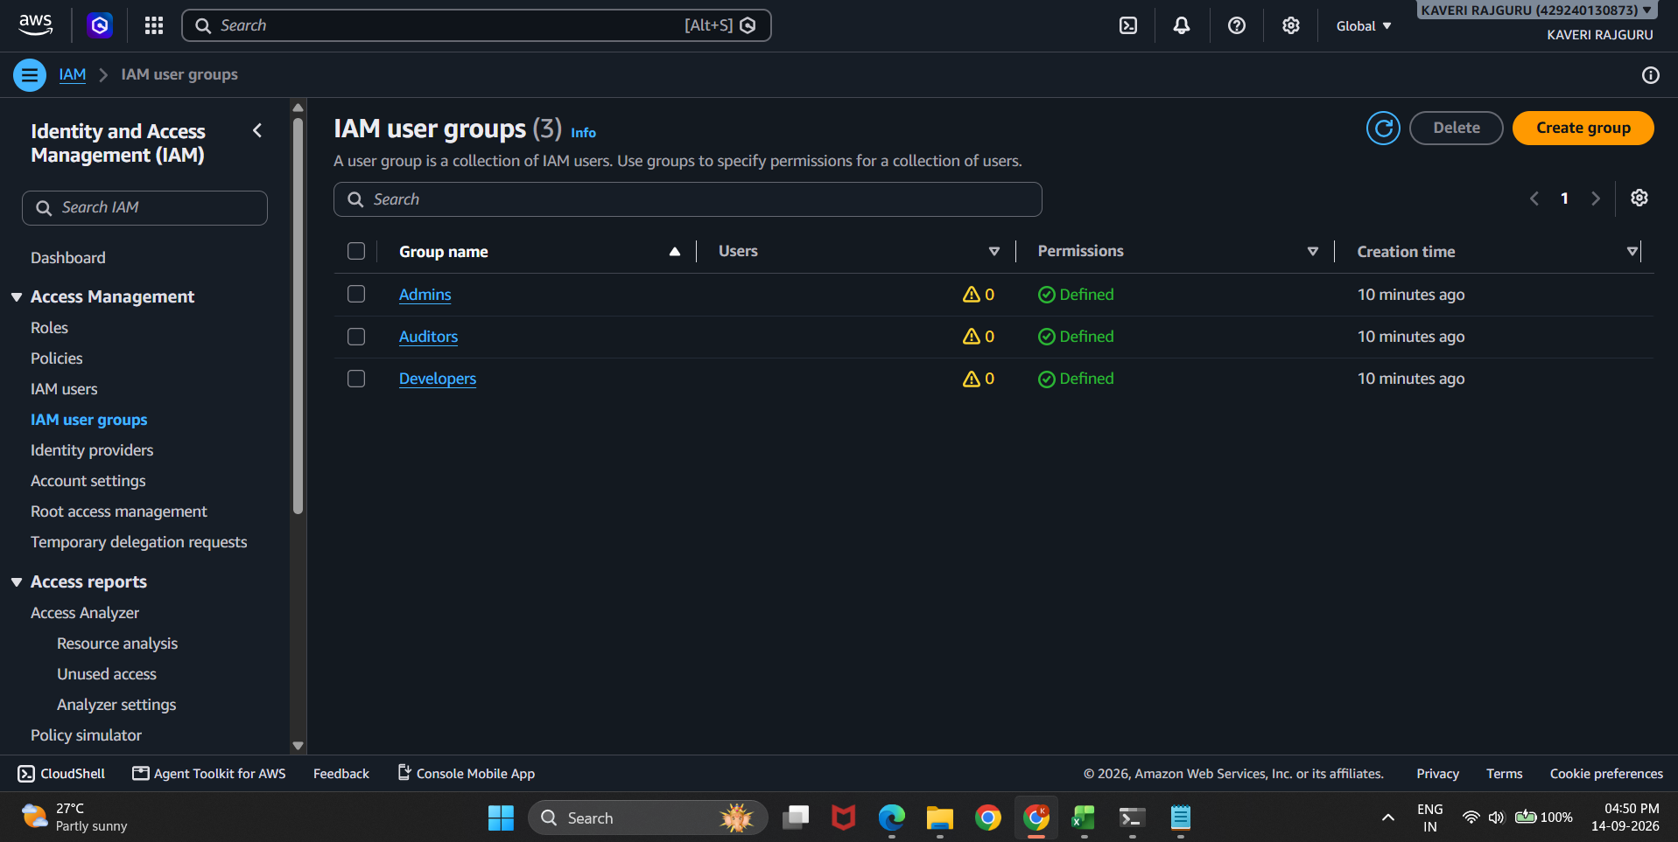
The AWS Console confirms all three IAM groups — Admins, Auditors, and Developers — were created, each with permissions defined.
Screenshot 5 — Admins Group MFA Enforcement
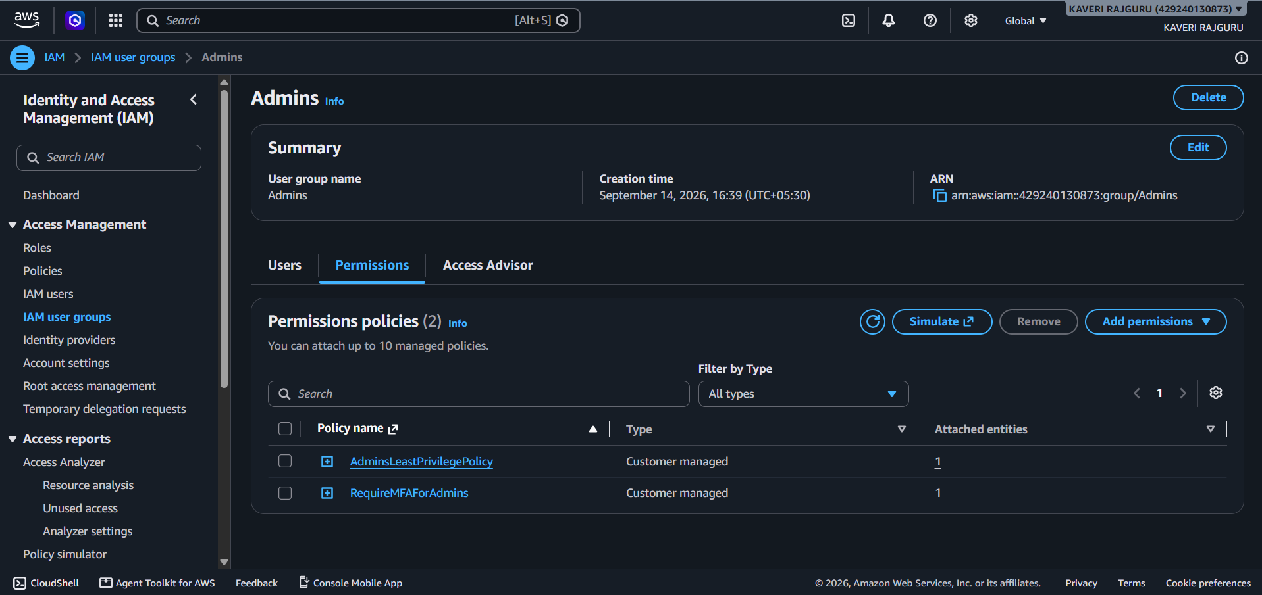
The Admins group has two policies attached: AdminsLeastPrivilegePolicy (scoped admin permissions) and RequireMFAForAdmins (denies actions unless MFA is present).
Screenshot 6 — EC2-S3-Access-Role Trust Policy
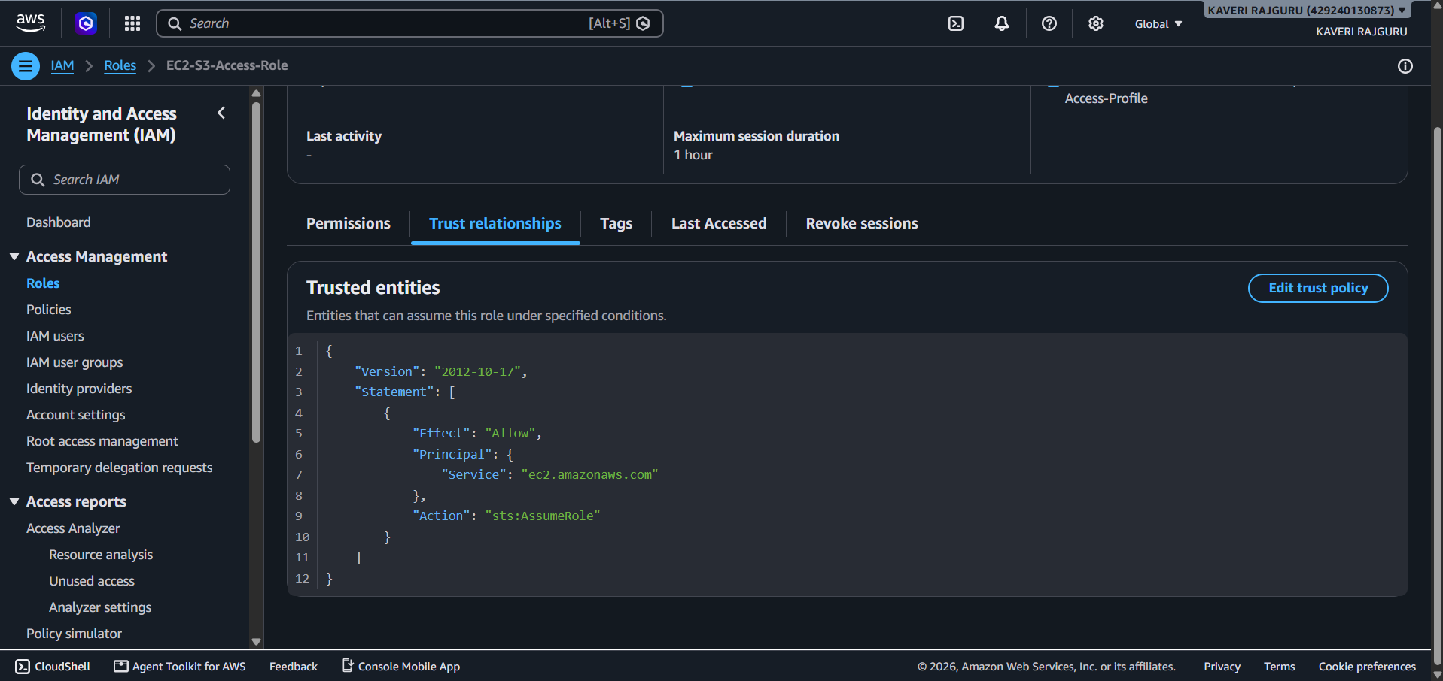
The custom IAM role's trust relationship allows only the EC2 service (ec2.amazonaws.com) to assume it via sts:AssumeRole, enabling credential-free access from EC2 instances.
Screenshot 7 — S3 Bucket Created
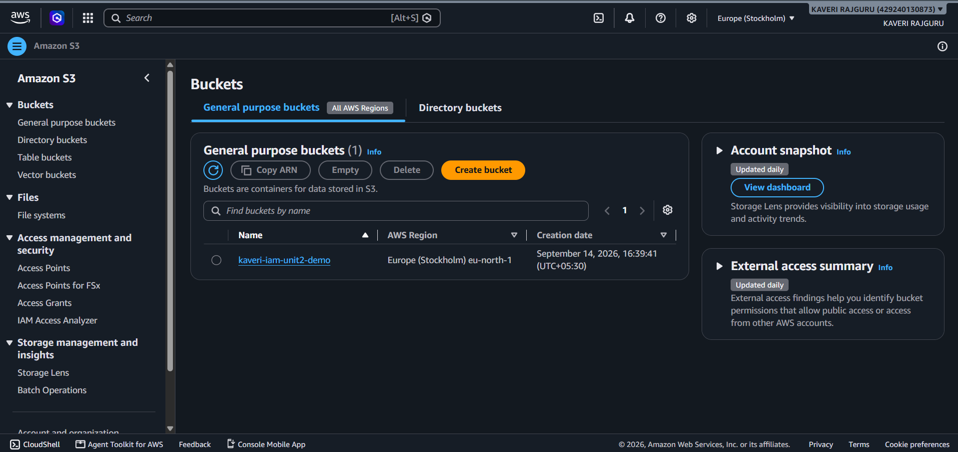
The application S3 bucket (kaveri-iam-unit2-demo) was provisioned in the eu-north-1 (Stockholm) region and is the target of the scoped Developer and EC2-role S3 permissions.

5. Source Code Repository
The complete Terraform source code, README documentation, and all screenshots have been published to GitHub:
https://github.com/kaverii18/iam-least-privilege

6. Conclusion
This project demonstrates a working, least-privilege IAM structure enforced through infrastructure-as-code. Each role's permissions are scoped to the minimum required for its function, administrative access is gated behind MFA, and EC2-to-S3 communication is handled through a temporary, role-assumed credential model rather than static access keys — meeting all requirements of the Unit 2 assignment.

